

A Project Report On

**OPPORTUNITY CIRCLE**

**By**

## ROOPALI CHAURASIA

**B.E.**

**Batch: - 2021-5735**

Under the Guidance of,

## SHALINI KUMARI

## Technical Trainer

**EduBridge**

(School of Coding)

# Introduction:

This Project **OPPORTUNITY CIRCLE** has been developed in **Java, JSP, and MySQL**. The purpose of this platform is to provide Training & Placement opportunities to the student or jobseekers.

In this project, Student can find a training institute for themselves. Students can find the training courses as per their skills. Also Institutes can add themselves and their offered courses.

Software Requirements:

Server: ApacheTomcatv8.5V

IDE: Eclipse IDE for Java EE Developers

Operating System: Window 10

Language Used : core java

Concept Used : Switch-case

Loops

Methods

Array

String

Classes used:

1. Web

2. Softwaretesting

3. CyberSecurity

4. DataAnalyst

Method Used:

1.Webdevelopment_Add_info()

2.Webdevelopmentaa_info()

3.Software_testing_Addinfo()

4.SoftwareTestinginfo()

5.CyberSecurity_info()

6.Show_CyberSecurity_info()

7. NewEntry_DataAnalyst()

8. Show_DataAnalyst()

**Home Page:**

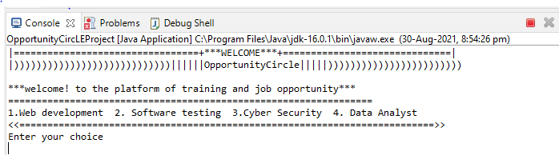

**Entering Choice:**

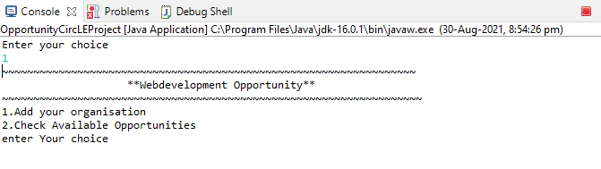

**Entering choice for adding organization or checking available opportunities:**

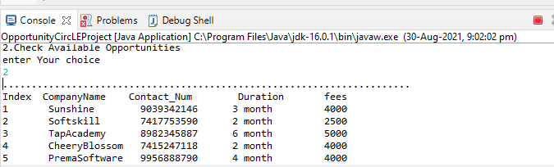

**Adding Organization Details:**

